**Group Number:** 3

**Group Members:**

|  |  |  |
| --- | --- | --- |
| Name - EID | % Contribution to UI design | % Contribution to paper |
| Ben Nguyen - bpn252 |  |  |
| Chris Cale – clc3648 |  |  |
|  |  |  |

**ApplicationName:** BuildABudget

**Application Description:**

This application assists users in building and maintaining a budget so that they can meet their financial goals. Users will stipulate the sources of their regular monthly income and expenses, as well as, their financial goals, such as saving up for a dream vacation, to enable them to generate a monthly budget plan. The application will utilize easy to understand visualizations, such as check lists and bar graphs, to inform the user of their progress toward meeting their goals and budgets, as well as, allowing them to test the impact that one-time transactions will cause. Users will be able to generate itemized transaction reports and export their financial data. Lastly the application will employ notifications to encourage and keep the user on track to meet their planned budgets and financial goals.

**Mockups:**

Login Screen

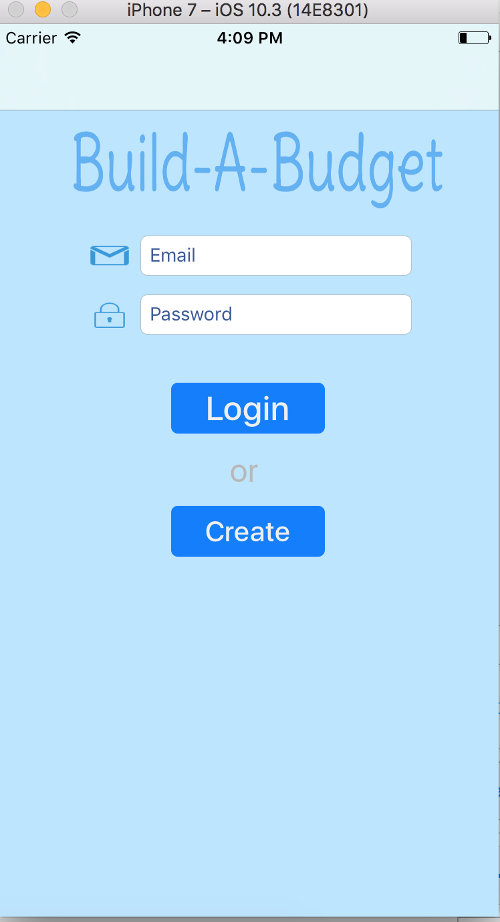

This screen is where the user can login or create an account. If the user wishes to login to his current account, he must enter both his email address (which serves as his username) and his password. The user can also create a new account to use the app. Clicking on the 'Create' button will take the user to the create account screen.

This screen is where the user can login or create an account. If the user wishes to login to his current account, he must enter both his email address (which serves as his username) and his password. The user can also create a new account to use the app. Clicking on the 'Create' button will take the user to the create account screen.

Settings Screen

Create Account Screen

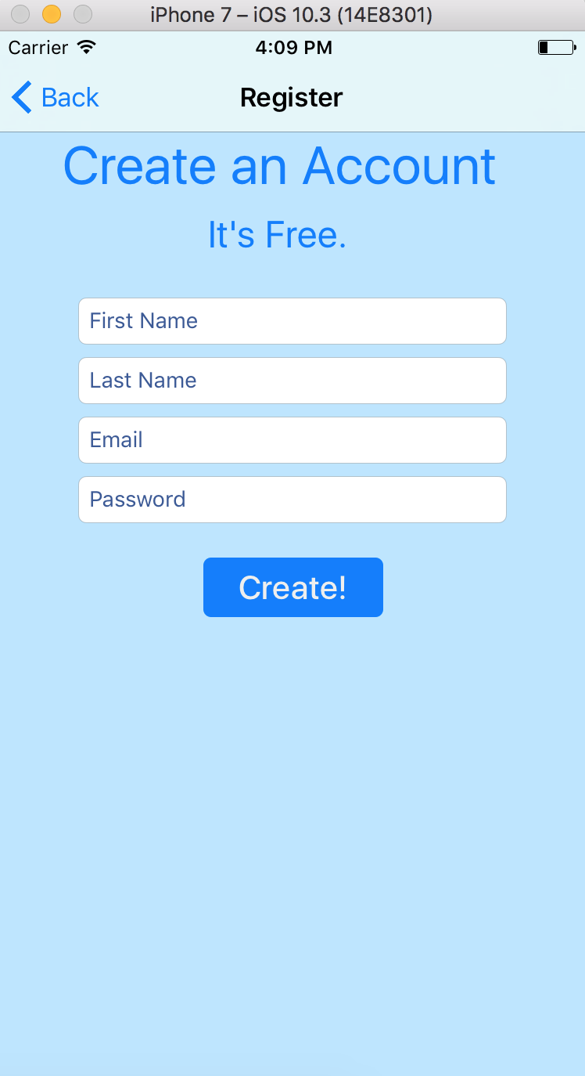  
  
This is where a new user can create a new account so he can start using the app. The user must provide both his first and last name. His email address will be used as his username to login in. Of course, a password is required as well. The 'Create!' button will create the account, assuming that an account with that email address hasn't already been taken.

Launch Screen:



The launch screen is where the user will first see when the user first launches the app. There is nothing for the user to do besides to wait for the app to take him to the logins screen.

Over View:

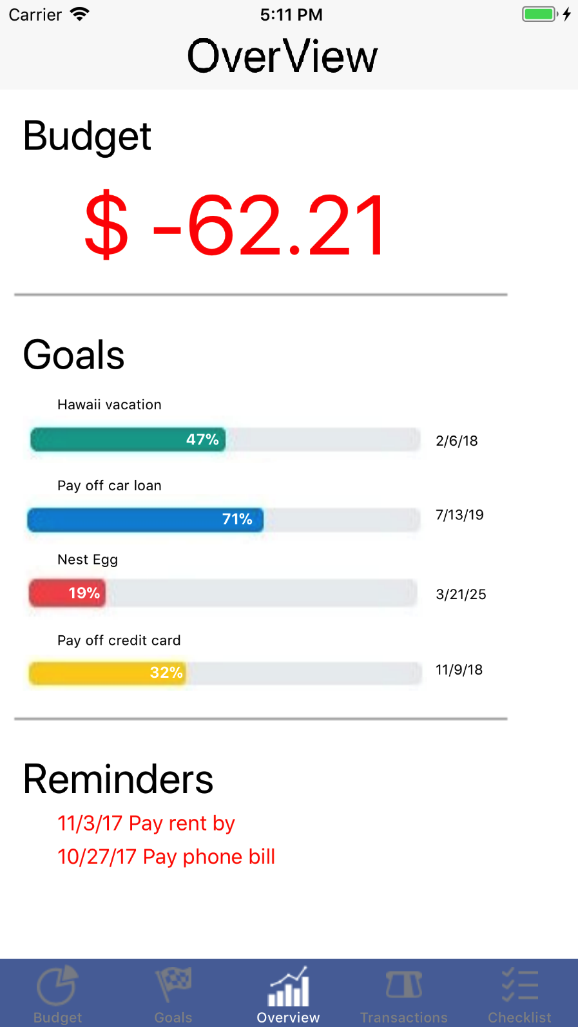

The overview screen is the default screen that the user lands on after logging in. The overview tab view controller functions as an aggregation of status highlights of the most important information contained in the app. The user will first see the prominent heading Budget which provides their current financial status in relation to their budget. The figure will be either a negative red number or a positive black number. The red color serves to reinforce that this is a negative amount so that it cannot be misinterpreted during a glance.

The Goals heading indicates to the user that they can quickly glance at their progress on reaching their financial goals. Each financial goal has a smaller (in relation to the Goals heading) indented title to visually separate itself in this section of the screen. The goal title matches the user provided description that the user input when they originally set up the goal. Each goal also has a progress bar that provides both a visually distinct color, which serves to make that specific goal more identifiable at a glance, and percentage within the progress bar graphic to provide context to the amount the user has accomplished. Note, we did not provide the user with the percent remaining since this app seeks to reinforce the positive behavior of saving toward your goals, and not dwelling on how much is left to accomplish. The last piece of information each goal displays is the current expected completion date. This is provided here to bound the goal in a concrete date in order to reinforce that these are not passive whims, but rather measureable, achievable, plans that the user can look forward to completing.

The last section is the Reminders section and it serves as a form of reinforcement for keeping users vigilant of their near term obligations so that they can meet their goals. We included this here because the user will always land on this tab, but they can choose to ignore the Checklist tab that actually shows their monthly bills.

Goals:

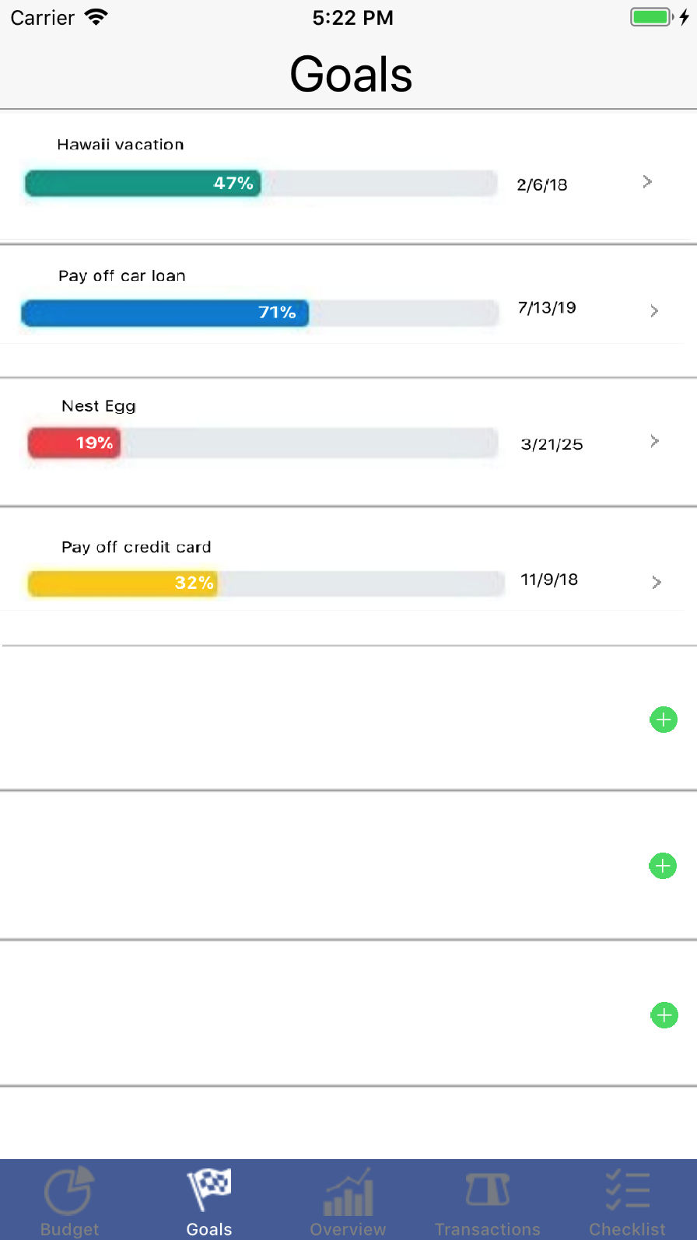

The Goals tab view controller seeks to list all the user’s active financial goals in a list ordered by creation date to make goals easier to search, since it is assumed that user remembers roughly if a certain goal is older than another one. Furthermore, the assumption that older goals will be have had more time to mature will mean that typically the user will see more goals that are closer to completion as soon as they open this tab thereby creating a positive visual reinforcement that encourages users to keep pursing their goals because the first few goals they see will likely be closer to completion. Note that completed goals are automatically removed the day after they are completed thus alleviating the need for unnecessary work on the user’s part to sort their Goals, while keeping a clean and relevant set of goals displayed. Each goal does provide an arrow that indicates to the user that there is further options on this goal which will lead them to the Edit Goal view controller where they may edit or delete this goal.

Lastly this list of Goals displays a green plus sign button on the next available cells in order to invite the user to add to their set of goals.

Edit Goals:

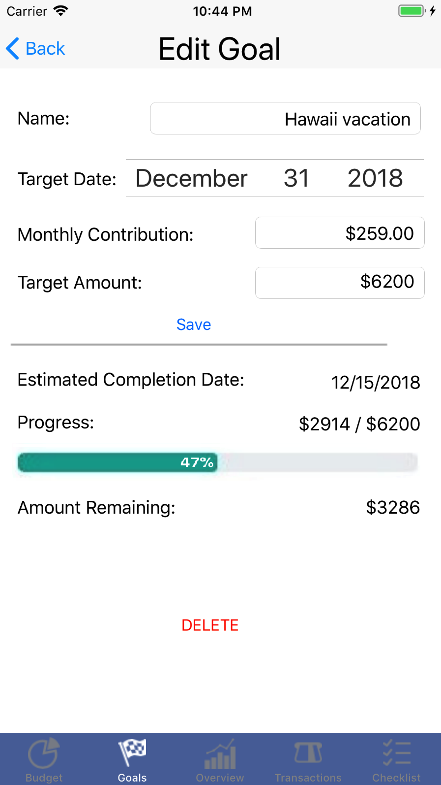

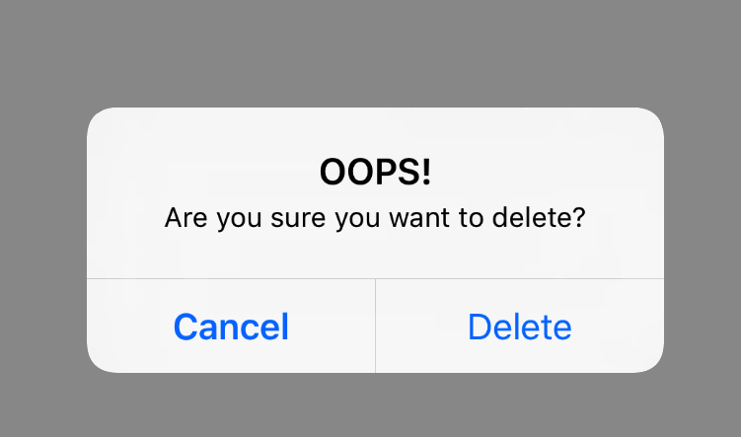

The Edit Goals view controller is only accessible by clicking on the edit arrow adjacent to the Goal in the Goals view controller the user wants to edit. This is done to avoid unintended clicks and to maintain an easy to remember work flow for the user. This view controller provides two sections that are visually separated by a bar to distinguish the editable information from the un-editable data that this goal has already generated.

The user will fill in the three text fields and the date selector to that set the parameters that identify this goal: the name; that identify the completion conditions: the target amount and target date; and that allows the user to input the rate by which they will save every month in order to reach this target amount. Note: the app will not allow the user to set a completion date that is any newer than tomorrow, since goals are defined as needing a measured time and we only measure in units of days and greater. Also the user will be prompted to correct a monthly contribution that is below the rate required by the target date to achieve. The goal’s information will always be populated in these editable fields when the user views this view controller because the user is allowed to edit a goal at any time and the progress will adjust accordingly. The save button is grouped with the editable information so that its purpose is not misconstrued, but it is far enough away from the editable fields as to provide sufficient space for unintended edits being saved. Also, if any information was edited, even if by accident, the information is not changed unless the save button is pressed. This is to avoid unintended edits.

<add note here about where the contribution amount is sent to -> checklist (as a bill)>

The lower section shows the user what date their goal is estimated to mature based on

the above data input and provides an exact dollar amounts for how much has been set aside each month toward this goal as well as how much remains. These dollar amounts are not displayed elsewhere because we are trying to exploit the same retail tricks that commercial ventures use when trying to get consumers to spend more money than they need to: we focus the user on saving a low monthly amount instead of a high final target amount so that the user sees each monthly contribution toward their goal as manageable and we do not prominently remind them of how much they have saved to avoid them from feeling the urge to spend money that they have already set aside for this goal.

Lastly we provide a delete button here that prompts the user to verify they actually want to delete the goal because accidently clicks happen, and sometimes certain goals become no longer relevant.